Assignment 9
PNR: 260740150018
Name: PRATIK SUNIL ABHANG
Question:
Write a function apply_discount(price, discount_percentage) where:
• An assert statement checks that discount_percentage is strictly between 0 and 100.
• Another assert statement checks that the final price is never negative or higher than the original price.
• Test your function with a valid discount (e.g., 20%) and an invalid discount (e.g., 120%) to show the traceback.
Program
def apply_discount(price, discount_percentage):
assert 0 < discount_percentage < 100, "Discount percentage must be between 0 and 100"
final_price = price - (price * discount_percentage / 100)
assert 0 <= final_price <= price, "Final price is invalid"
return final_price
print("Valid discount:")
print(apply_discount(1000, 20))
print("\nInvalid discount:")
print(apply_discount(1000, 120))

Input and Output
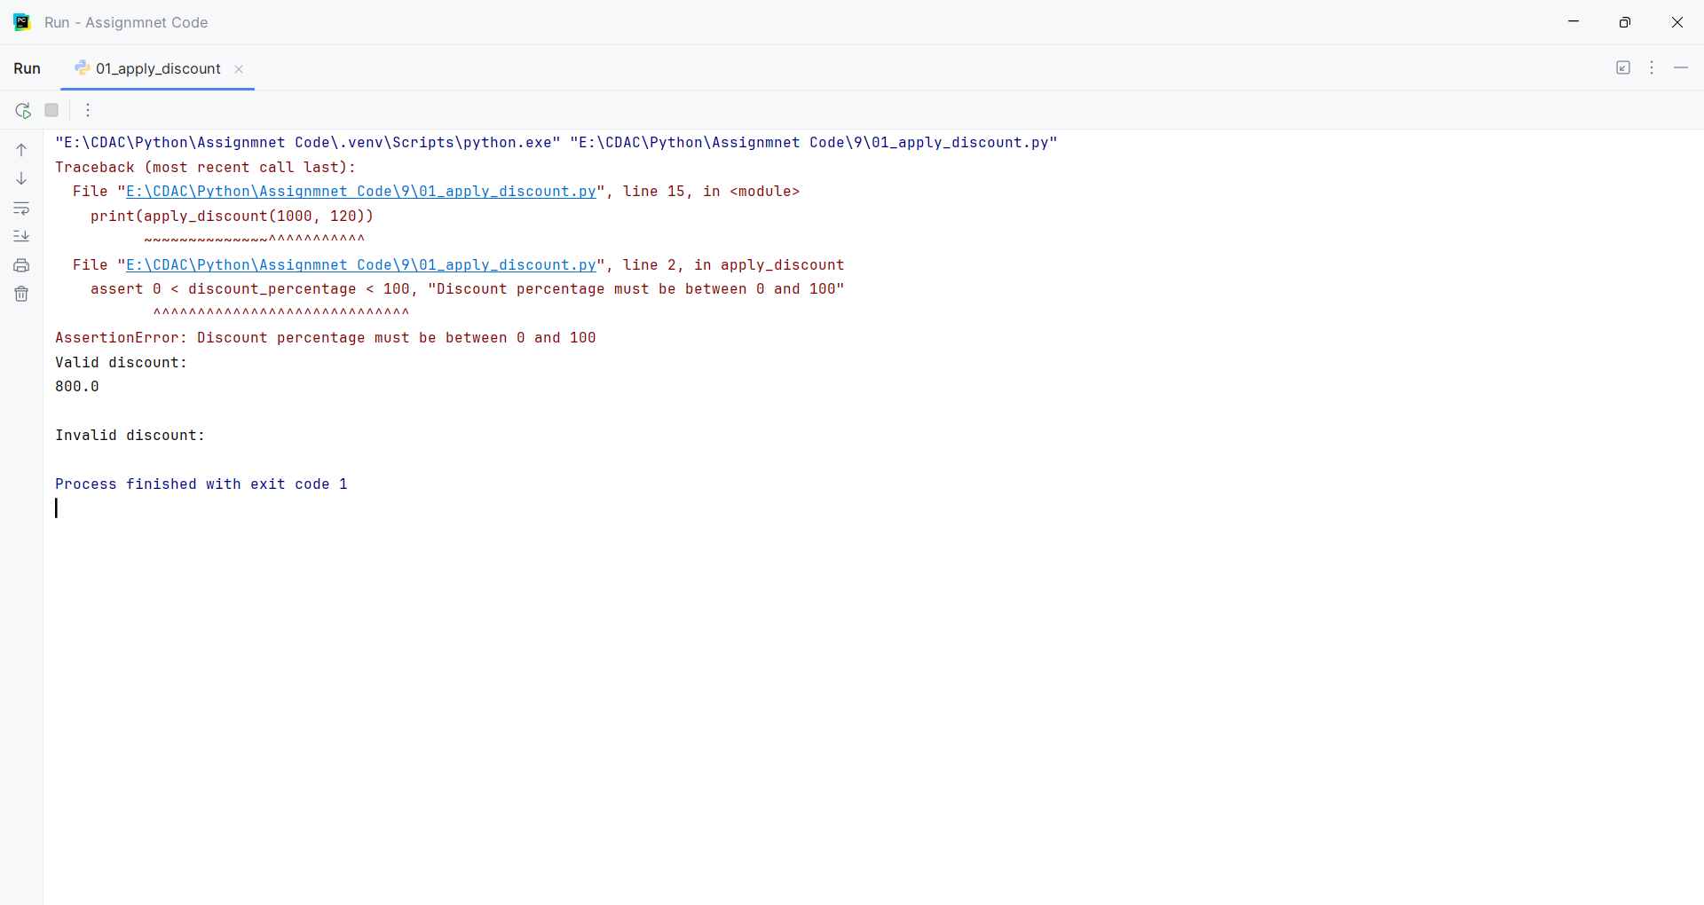
Question:
Create a program that prompts the user to enter two numbers (A and B) and outputs the result of A / B. Wrap the execution inside a try block and implement specific except clauses to handle.
• ValueError: Handled when a user inputs a non-numeric string (e.g., "abc").
• ZeroDivisionError: Handled when B is zero.
Program
try:
A = float(input("Enter number A: "))
B = float(input("Enter number B: "))
result = A / B
print("Result =", result)
except ValueError:
print("Error: Please enter numeric values only.")
except ZeroDivisionError:
print("Error: Cannot divide by zero.")

Input and Output
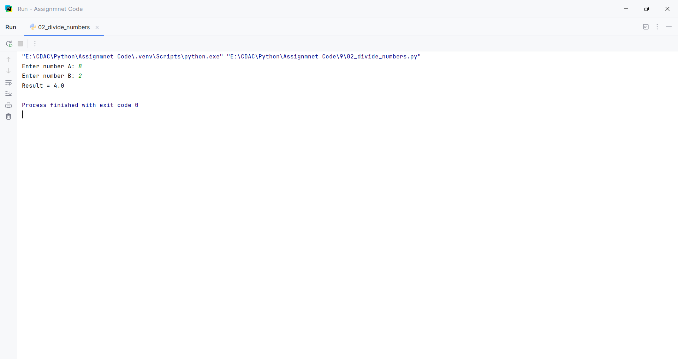
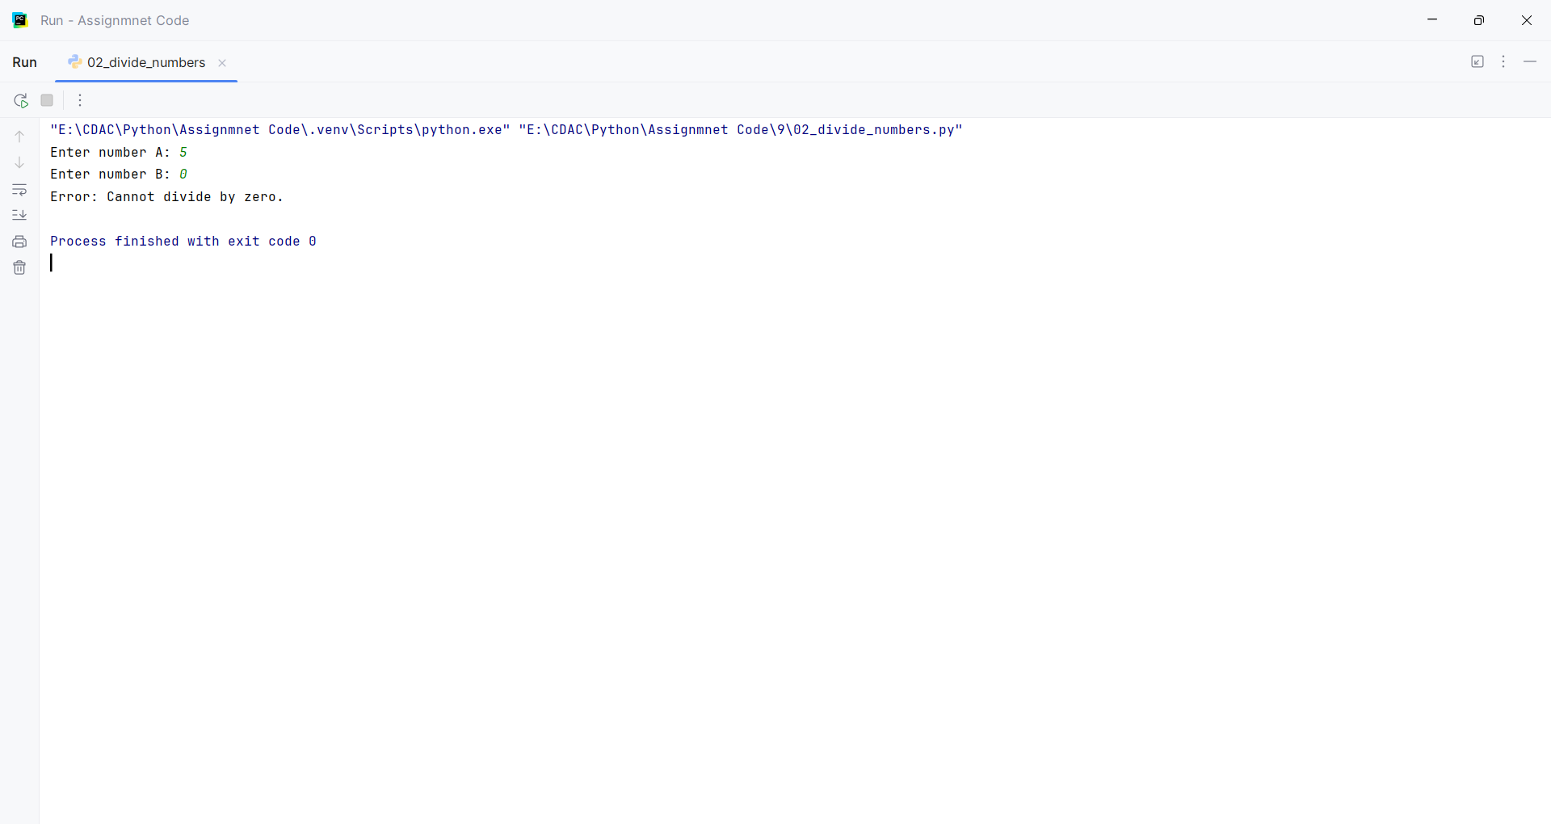
Question:
Write a program that requests a filename from the user and attempts to open it in read-only mode.
• Intercept FileNotFoundError if the file doesn't exist.
• Intercept PermissionError if the user lacks the credentials to open the file
Program
filename = input("Enter the filename: ")
try:
file = open(filename, "r")
print(file.read())
file.close()
except FileNotFoundError:
print("Error: File does not exist.")
except PermissionError:
print("Error: You do not have permission to open this file.")

Input and Output
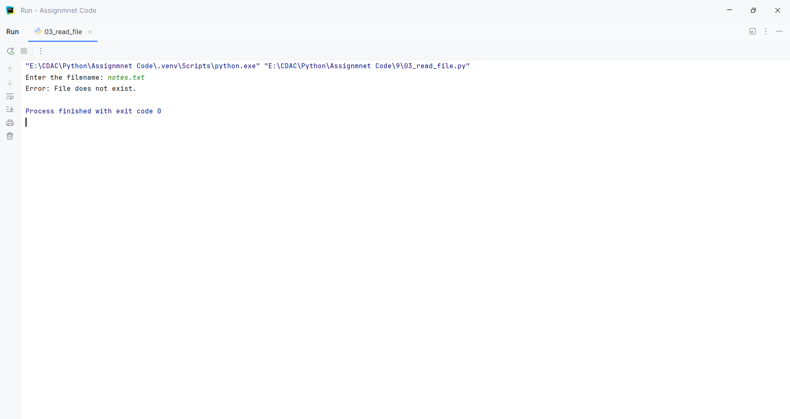
Question:
Create a class named Countdown.
• The constructor __init__(self, start) should accept a starting integer.
• Implement __iter__(self) to return the iterator object itself.
• Implement __next__(self) to return numbers counting down to 0.
• Once it hits 0, it should raise a StopIteration exception to halt the loop.
Program
class Countdown:
def __init__(self, start):
self.start = start
def __iter__(self):
return self
def __next__(self):
if self.start < 0:
raise StopIteration
current = self.start
self.start -= 1
return current
countdown = Countdown(5)
for number in countdown:
print(number)

Input and Output
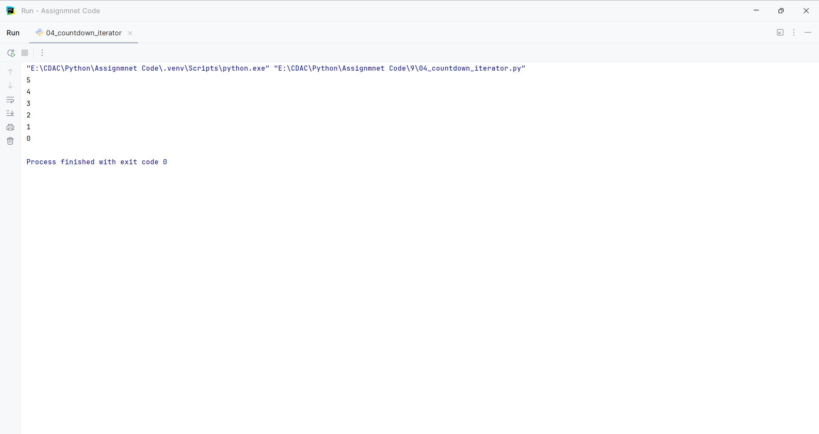
Question:
Write a generator function named fibonacci_gen(limit).
• It should calculate and yield Fibonacci numbers one by one.
• The generator must stop yielding once a number exceeds the specified limit.
Program
def fibonacci_gen(limit):
a = 0
b = 1
while a <= limit:
yield a
a, b = b, a + b
limit = int(input("Enter the limit: "))
for number in fibonacci_gen(limit):
print(number)

Input and Output
